**Final Year Research Topic**

**Vulnerability Tracker**

There is a government compliance to scan the servers so currently it is scanned by manually those tasks are automated by this system. In this system the servers’ vulnerabilities will be fixed by assigning them to relevant person in the organization. When it fixed by the assigned user it will forwarded to the department who assigned the task. That department will be checked if it fixed by scanning the server then the status will be updated as the vulnerability is fixed if it is still not fixed the status will be not updated. There are some scenarios the assigned user will reject the assigned tasks since it is note related to them. So that tasks must be assigned to a related user again by that assigning department.

### **Maintain the Server details with the priority level.**

#### Include the live server details with the priority basis.

#### Include the V/A scanning schedule according to the priority basis of the servers

#### Include tags related to server details (Ex:- O/S version, Web application, Service)

#### Include scan details, followup details and escalation details

#### System shall allow to browse a particular server and view the details

#### The system shall display detailed information of the on boarded server

### **Add/Remove/Update server details.**

#### The system shall allow to add/remove/update server details on user basis

#### The system shall allow to add V/A scan details on the following categories App

DB, O/S

# The system shall allow to update Vulnerability status after fixing by the responsible party

### **Provide Search facility.**

* The system shall enable user to search particular server details by providing a keyword
* The system shall enable user to select multiple options on the screen to search.
* The system shall display all the matching products based on the search.
* The system shall enable user to navigate between the search results.
* The system shall notify the user when no matching product is found on the search.

### **Maintain user profile.**

* The system shall allow user to create profile and set his credential.
* The system shall authenticate user credentials to view the profile.
* The system shall allow user to update the profile information.
* The system shall allow user to commit the fixed vulnerability from the system.
* The system shall display assigned vulnerabilities of the particular servers to the users

### **Provide personalized profile**

### .

* The system shall display V/A scan history in the user profile.
* The system shall allow user to assign vulnerabilities to particular business units.
* The system shall display the detailed information about the selected server.
* The system shall allow to over-right committed tasks of a particular user by the admin account.

### **Email confirmation.**

* The system shall maintain user’s email information as a required part of customer profile.
* The system shall send an email to the respective user when a particular vulnerability was assigned.
* The system shall send follow-up emails for the users based on the assigned vulnerabilities.
* The system shall escalate the follow-up to next line on command when first two followups didn’t get any reply
* The system shall display all the followup details

### **Report Generation.**

* The system shall display customized reports based on the imputed content.

Domain controller

Database

Application

Server Type

Non - Critical

Public facing

Critical Servers

V/A scan Schedule

Escalation party

Fixing schedule

Criticality

Vulnerabilities

Vulnerabilities

V/A scan Schedule

Followup dates

Previous Scan dates

Next Scan Date

Scan Date

Non - Critical

Public facing

Critical

Server Criticality

Responsible person

Server Name

Current V/A scan status

IP Address

Server Type

Scan Date

Server Criticality

Server

**Loyalty Points Exchanger System**

The loyal cards are the same for all companies. User can register their loyalty card for any registered company. Users can access the app we developed to check the available loyalty points, and discounts available in the company. The novelty of the system is that if users forgot to bring their loyalty cards user can use the mobile application, we developed to generate the QR code, so the company can scan it from the web application to redeem the points of the user. Companies can retrieve the user points by scanning the card or QR code. All the users are managed using blockchain and cloud technology. Users and companies have 2 different portals to authenticate and login to the system.

Maintain the user profile

* The system will allow the user to create a profile and set his credential.
* The system will allow the user to reset their passwords
* The system will allow them to update their profile details
* Display the points, balance, points used and total points
* Change the password or reset the password

Provide some details

* About the companies (especially discounts, seasonal offers, and raffle draws)
* Gifts and Gift Vouchers for the loyalty points

Manage loyalty points

* Add loyalty points
* Deduct the loyalty points
* Calculate the balance loyalty points

**ER Diagram**

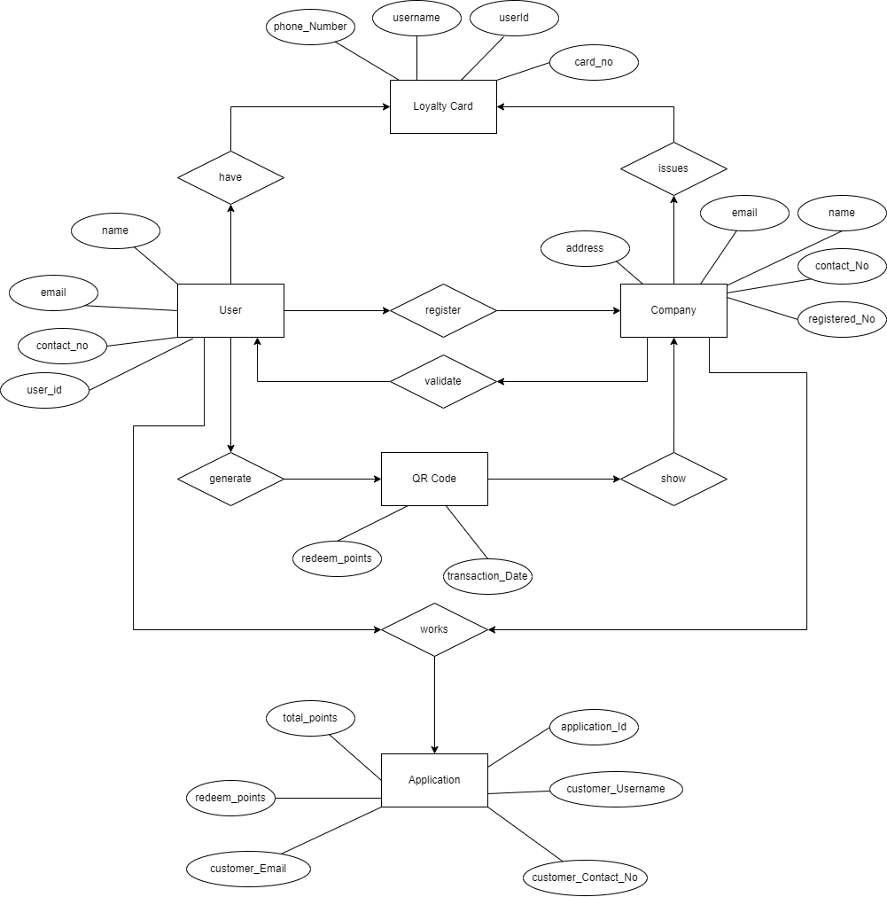

**References**

**Research Papers for Loyalty Points Exchanger System**

<https://ieeexplore.ieee.org/document/9284795>

<https://www.cambridge.org/core/journals/knowledge-engineering-review/article/abs/loyalty-program-based-on-waves-blockchain-and-mobile-phone-interactions/5C501BA2BE5B8D296B1498792C080843>

<https://ieeexplore.ieee.org/document/9417501>

**Research Papers for Vulnerability management automation**

<https://link.springer.com/article/10.1007/s42979-022-01271-1>

<https://www.sciencedirect.com/science/article/pii/S1877050917304568>

<https://ieeexplore.ieee.org/document/8997964>